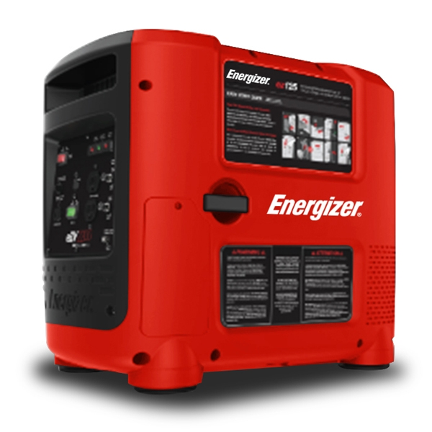

EZG SERIES
USER GUIDE

©2018 Energizer. Energizer and certain graphic designs are trademarks of Energizer Brands,
LLC and related subsidiaries and are used under license by Builder SAS.
All other brand names are trademarks of their respective owners.
Neither Builder SAS nor Energizer Brands, LLC is affiliated with the respective owners of their trademarks

Thanks for choosing the EZG Series!
You're excited to power up, so we'll keep this brief. Let's get started!

CONTENTS | PAGE
Safety First | 8
Safety while using your generator | 8
Understanding AC safety | 9
Safety while maintaining your generator | 9
Other safety tips | 10
Learn About Your Generator | 11
Identification of componants | 11
Making sure you have everything | 13
Setting Up Your Generator | 14
Checking the oil level | 14
Checking the air filter | 15
Using Your Generator | 17
Initial startup of your generator | 17
Operating your generator | 19
Shutting off your generator | 22
Using your generator with appliances | 23
Using the generator to charge automotive batteries | 23
Maintaining Your Generator | 25
Maintainance Schedule | 25
General inspection tips | 25
Cleaning the air filter | 26
Changing the engine oil | 27
Replacing and cleaning the spark plug | 28
Handling and storage | 29
Troubleshooting | 30
Specifications | 34
Wiring Diagram | 35

Chapter 1 — Safety First

Playing it safe when working with power equipment is always a good idea. Here are some important precautions to make sure you stay safe.

  - Safety while Operating Your Generator
    - Always perform an oil, fuel and air filter check before starting the engine.
    - Properly clean and maintain the equipment.
    - Operate the generator according to instructions for safe and dependable service.
    - Before operating the generator, read the user guide carefully. Otherwise, it may result in personal injuries or equipment damage.
    - Never run the generator in an enclosed area to avoid harm from exhaust emissions of a poisonous carbon monoxide gas.
    - The engine exhaust from this product contains chemicals known to cause cancer, birth defects or other reproductive harm.
    - Be careful not to touch the exhaust system, compressor pump or discharge tubing during operation due to risk of burns.
    - Pay attention to the warning labels. The engine exhaust system will become heated during operation and remain hot immediately after the engine is stopped.
    - Gasoline is a highly flammable and explosive liquid. Refuel in a well ventilated area with the engine stopped.
    - This portable generator is not for use with gasoline/ethanol blends with over 15% ethanol.
    - When refueling the generator, keep it away from cigarettes, open flames, smoke and/or sparks.
    - Place the generator at least 3 feet away from buildings or other equipment during operation.
    - Run the generator on a level surface. Tilting the generator may result in fuel spills.
    - Know how to stop the generator quickly and understand operation of all the controls. Never permit anyone to operate the generator without proper instructions.
    - Keep children, pets and machinery with rotating parts away during

operation.
      - Do not operate the generator in rain or snow.
      - Do not allow any moisture to come in contact with the generator.
      - Do not touch the spark plug while the engine is operating or shortly after the engine has been shut down

Understanding AC Safety
Before connecting the generator to an electrical device or power cord:
    - Make sure that everything is in proper working order. Faulty devices or power cords can lead to an electrical shock.
    - Turn off the generator immediately if the device begins to operate abnormally. Then disconnect the device and investigate the problem.
    - Make sure that the electrical rating of the device does not exceed that of the generator. If the power level of the device is between the maximum output power and the running power of the generator, the generator should not be used for more than 30 minutes.
    - WARNING: Connections for standby power to a building’s electrical system must be done by a qualified electrician and must comply with all applicable laws and electrical codes (National Electrical Code, NFPA 70). Improper connections may cause serious injuries to electrical workers during a power outage, and when the utility power is restored, the generator
may explode or cause fires. The generator shall be connected through transfer equipment that switches all conductors other than the equipment grounding conductor. The frame of the generator shall be connected to an approved grounding electrode.
    - For power outages, permanently installed stationary generators are better suited for providing backup power to the home. Even a properly connected portable generator can become overloaded. This may result in overheating or stressing the generator components, possibly leading to a generator failure.

Safety while Maintaining Your Generator
- After any maintenance is performed, wash immediately using soap and clean water because repeated exposure to lubricant may cause skin irritation.

    - Do not clean the filter element with flammable liquids like gasoline because an explosion may occur.
    - Turn off the engine before performing any maintenance. Otherwise it can cause severe personal injury or death.
    - Allow the generator set to cool down before performing any maintenance.
    - Always wear safety glasses when cleaning the generator set with air.
    - Do not clean the generator set with a pressure washer because it can cause damage to the generator set.
    - Before working with batteries, ventilate the area, wear safety glasses, do not smoke and always disconnect the negative cable first and reconnect it last.
    - Use rubber gloves when coming into contact with engine oil.
    - Always stop the generator set before removing the oil filler cap.
    - Only qualified maintenance personnel with knowledge of fuels, electricity, and machinery hazards should perform maintenance procedures.
    - Lubricate all exposed metal parts regularly. See chapter 5.1 for maintenance schedule.

Other Safety Tips
    - To avoid breathing in poisonous carbon monoxide from the exhaust gases, adequate ventilation should be provided if the generator set is running in a partially enclosed space.
    - If the generator set is stored outdoors, check all the electrical components on the control panel before each use. Moisture can damage the generator and can lead to an electric shock.
    - When storing gasoline or equipment with fuel in tank: store away from furnaces, stoves, water heaters or other appliances that have a pilot light or other ignition source because they can ignite gasoline vapors.
    - Generators vibrate in normal use. During and after the use of the generator, inspect the generator as well as extension cords and power supply cords connected to it for damage resulting from vibration. Have damaged items repaired or replaced as necessary. Do not use plugs or cords that show signs of damage such as broken or cracked insulation or damaged blades.
    - If you start to feel sick, dizzy, or weak after the generator has been running, move to fresh air RIGHT AWAY. See a doctor. You could have carbon monoxide poisoning.

Chapter 2 — Learn About Your Generator

This section will show you how to identify key parts of your generator. Going over the terminology below will make sure we're on the same page.

Identification of Components

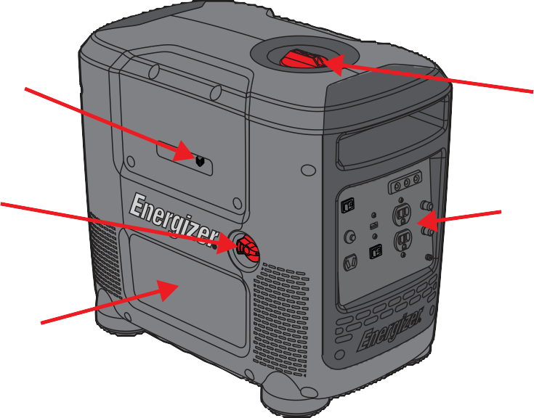
Choke Lever

Fuel Valve

Engine Access Panel

Battery Access Panel
Fuel Cap

Control Panel

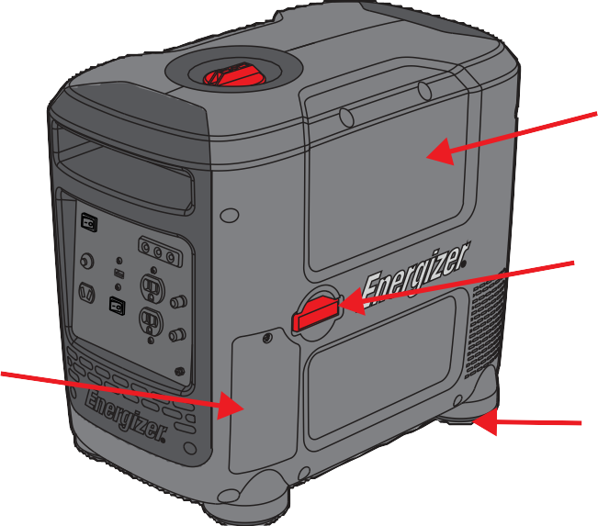
Spark Plug Access Panel

Recoil Starter
Handle

Rubber Feet

USB
Outlet
Output Light
Overload Light
Low Oil Light

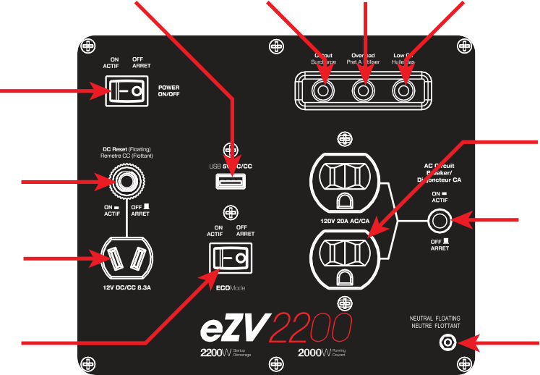
On/Off Ignition Switch

DC Reset

DC Outlet
EZG2200i

EcoMode Switch

AC Dual Outlet

20A Circuit Breaker

Ground

120V 30A
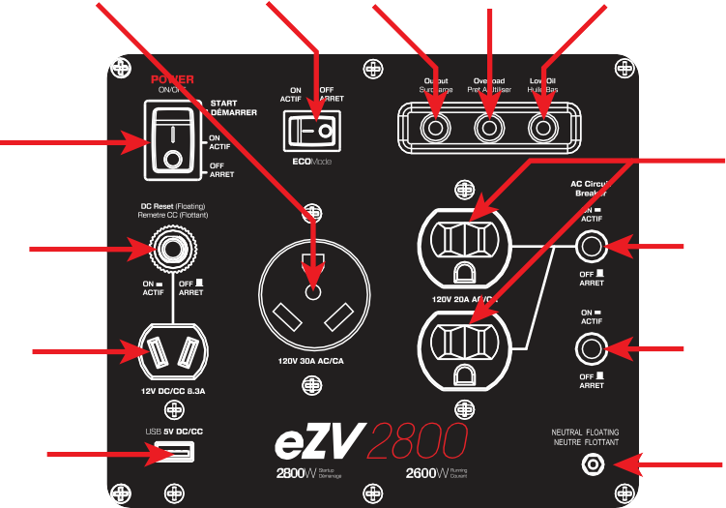
Outlet
EcoMode Switch
Output Light
Overload Light
Low Oil Light

On/Off Ignition Switch

DC Reset

DC Outlet
EZG2800i

USB Outlet

AC Dual Outlet

20A Circuit Breaker

30A Circuit Breaker

Ground

Make Sure You Have Everything

Part Name | Quantity
EZG series Generator | 1
User Guide | 1
DC Charging Cables | 1
450mL 10W30 Oil with Funnel | 1
Tool Kit | 1
Make sure your generator set has everything in the table above.

Chapter 3 — Setting Up your EZG series Generator

Setup should be done every time you start up your generator, these quick checks will ensure you get the most out of your generator.
is inadequate.
Exhaust gas contains poisonous carbon monoxide. Never run the generator in an enclosed area. Be sure to provide adequate ventilation. Operate the generator on a level surface. If the generator is tilted, fuel spillage may result. Keep away from moving parts while the generator is running. The generator is air-cooled and may be damaged if ventilation

Checking the Engine Oil Level
    - Ensure the generator is on a level surface.
    - Inspect engine oil:
    - Take out the oil filler cap and clean the dipstick.
    - Check the oil level by reinserting the oil filler cap without rotating it. Remove the oil filler cap and examine the oil level. If the oil level is at or below the minimum oil level, refill the oil to the maximum oil level mark.
    - Reinsert the oil filler cap and tighten securely.

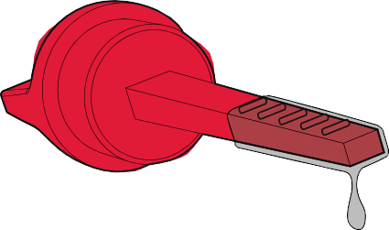
Maximum Oil Level
Minimum Oil Level

Engine oil is a major factor affecting engine performance and service life. Non-detergent or vegetable oils are not recommended.

fuel system components.
Gasoline substitutes are not recommended. They may be harmful to the

Gasoline is highly flammable and explosive under certain conditions. Refuel in a well-ventilated area with the engine stopped. Do not smoke or allow open flames or sparks in the area where the generator is being refueled or where gasoline is stored. Do not overfill the tank. Be careful
not to spill fuel when refueling. Wipe up any spilled gasoline and let the

Check the Air Filter
area dry before starting the engine.
    - Unscrew and remove the engine access panel. Remove the air filter element and observe for cleanliness.
    - Clean the air filter element with soap and water or solvent. Squeeze dry and then soak in clean engine oil.
    - Squeeze out all excess oil and reinstall. Replace the filter if it is damaged.

Check the air filter using the maintenance schedule. Always inspect air filter before using the generator. Clean Air Filter every 3 months or after 50hrs of operation according to Section 5.3 Cleaning the Air Filter.

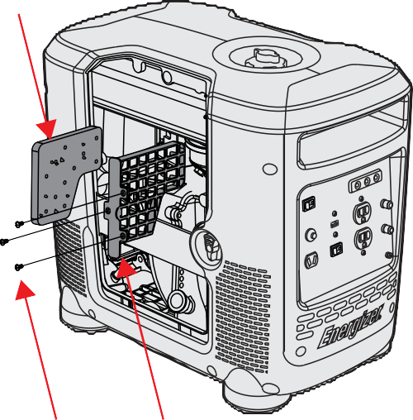
Air Filter Sponge

Engine Access Panel
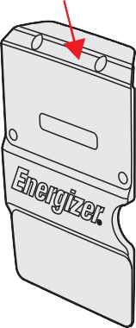
Screws Air Filter Cover

Chapter 4 — Using Your EZG series Generator

DANGER - CARBON MONOXIDE
Using a generator indoors WILL KILL YOU IN MINUTES.

Generator exhaust contains carbon monoxide (CO). This is a poison you cannot see or smell. If you can smell the generator exhaust, you are breathing CO. But even if you cannot smell the exhaust, you could be breathing CO.
- NEVER use a generator inside homes, garages, crawlspaces, or other partly enclosed areas. Deadly levels of carbon monoxide can build up in these areas. Using a fan or opening windows and doors does NOT supply enough fresh air.
- ONLY use a generator outside and far away from windows, doors, and vents. These openings can pull in generator exhaust.
- Even when you use a generator correctly, CO may leak into the home. ALWAYS use a battery-powered or battery-backup CO alarm in the home.
- If you start to feel sick, dizzy, or weak after the generator has been running, move to fresh air RIGHT AWAY and seek medical attention. You could have carbon monoxide poisoning.
consult a qualified electrician.
Before using generator, a ground wire must be connected to the ground terminal.
The Ground terminal is located on the Front Panel. Before using the ground terminal

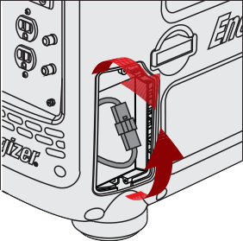
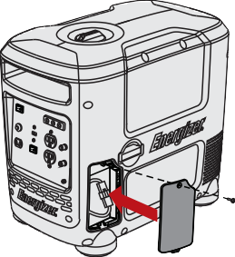
  - Initial Setup of Your Generator

We know you're excited to get using your generator. Please be sure to follow the setup, operation, and shut off instructions below thoroughly to ensure the best lifespan for your generator.

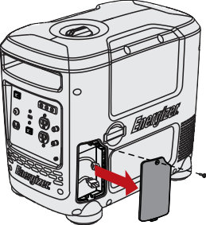
Steps 1-3 are for the EZG2800i. If you have an EZG2200i start on Step 4.

1. Setup the Battery: Remove the Battery Access Panel from the unit by unscrewing the screw at the top and releasing the panel.
2. Connect the Battery: locate and connect the loose connectors from the battery wiring harness and the main wiring harness. The battery is now connected to the unit.
3. Re-install the Battery Access Panel onto the unit. Ensure the screw is fastened properly.
4. Remove the main engine access panel from the unit by unscrewing the (4) screws at the top and middle of the unit.

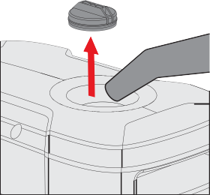
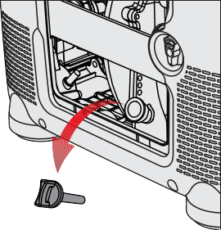
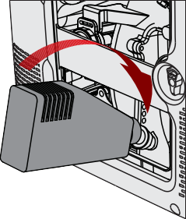
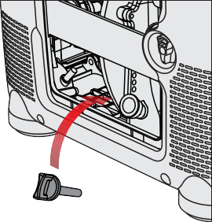
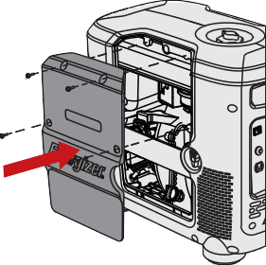

5. Locate, unscrew, and remove the Oil Dipstick, exposing the internal engine compartment. Be sure not to allow any dust or debris near the engine during this time.
6. Pour in the full contents of the 450 mL oil bottle provided with your unit, or fill to the full mark located on the dipstick.
7. Re-install the Oil Dipstick and fasten tightly. Wipe away any excess oil. For best results, drain and refill the engine oil after the first 20 hrs of use, and every 50 hrs thereafter.
Do not remove the Oil Dipstick when the engine is warm from prior use.
8. Re-install the Engine Access Panel onto the unit, ensur- ing that all (4) screws are fastened properly.
9. Remove the fuel cap, exposing the fuel tank . Be sure not to allow any dust or debris near the engine during this time. Pour 91 octane unleaded gasoline into fuel tank, add Ethanol ShieldTM to fuel tank as directed on bottle, and replace the fuel cap.

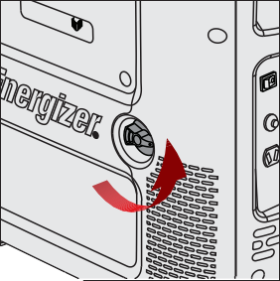
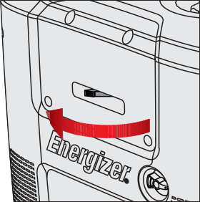
  - Operating Your Generator - Manual Start

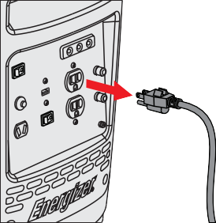
All EZG generators can be started using the manual starting method. EZG models that include batteries can also be started using the convenient electric start method on page 21, these models also include an automatic choke.

1. Disconnect all devices from the generator.
2. Open the fuel valve: turn the fuel valve from "off" to "on". Make sure the valve is turned all the way on.
3. Turn choke to fully "Closed" position. Leave the choke in the "Open" position if the generator is still warm from recent use, or if the air temperature is higher than 50°F (10°C).
4. Turn Power switch to "On". Make sure EcoMode switch is set to "Off".

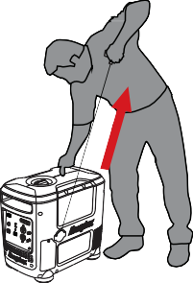
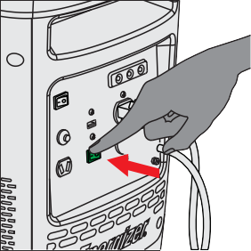
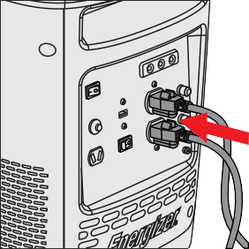
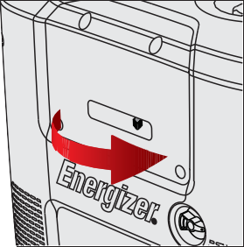

5. Pull Recoil handle until engine starts. Several pulls may be required until engine starts. Do not release the pull cord at the end of a pull, this will damage the recoil assembly. Bring the pull handle back down to the unit by hand.
6. Once the generator has started, wait at least 30 seconds for it to warm up, and then you may slowly open the choke lever until it is fully open.
7. Connect all of your devices to the generator.
8. Turn EcoMode switch to "On". This will reduce the output to a level where the generator will only produce enough power for the connected devices. The reduction of extra, unused power saves fuel.

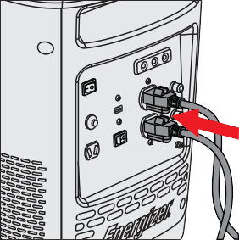
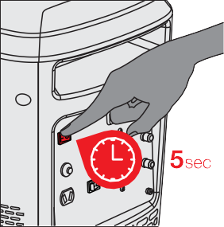
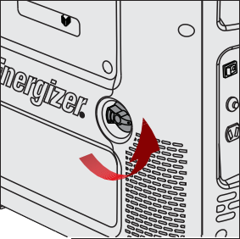
Operating Your Generator - Electric Start

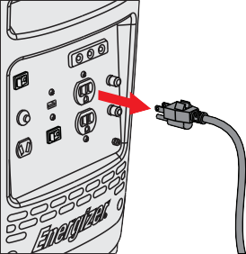
Only the EZG2800 is equipped with a battery, and can follow these instructions. It also has an automatic choke.

1. Disconnect all devices from the generator.
2. Open the fuel valve: turn the fuel valve from "off" to "on". Make sure the valve is turned all the way on.
3. Turn Power switch to "Start" for 5 seconds to start engine. If the engine does not start, the battery may be dead, follow manual start instructions to start the engine. Running the engine charges the battery.
4. Connect all of your devices to the generator and turn EcoMode switch to "On". This will reduce the output to a level where the generator will only produce enough power for the connected devices. The reduction of extra, unused power saves fuel.

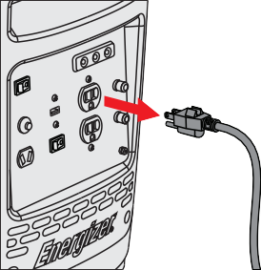
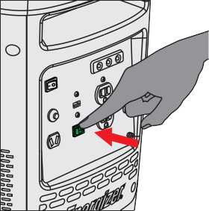
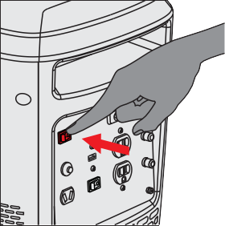
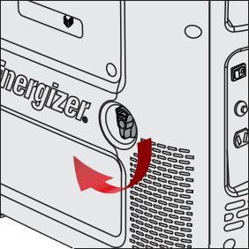
Shutting Off Your Generator

1. Disconnect all devices from the generator.
2. Turn EcoMode switch to "Off". Let generator run with EcoMode off for 2 minutes.
3. Turn Power switch to "Off".
4. Close the fuel valve by turning it to "Off".

To stop the engine in an emergency, turn the engine switch “OFF”. Always
connect the ground terminal at the front panel to the ground (earth) to prevent

electrical shock.

  - Using an EZG series generator with your Devices

After starting your generator you can connect your devices to it. Before starting, make sure that you know what you are able to power with your Generator. Here's how you can find out: Add the watt ratings of all the loads that the generator set will be powering at the same time. Make sure that total wattage will not exceed the generator rating.

For example: A generator set rated 5000W can power two 1500W heaters, a 900W circular saw, a 500W drill and a 100W light at the same time (4500W combined).
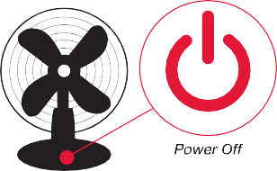
However, to operate a second 900W saw, it will be necessary to disconnect one of the 1500W heaters.

1. Turn off all devices before connecting them to your generator.
2. Insert the plug of the device into your generator based on its voltage requirements. Your EZG series generator includes two 120V AC outlets, one 5V USB outlet, and one 12V DC outlet for charging automotive batteries. See Section 4.5 before using the DC outlet.
3. You can now turn your devices on and use them.

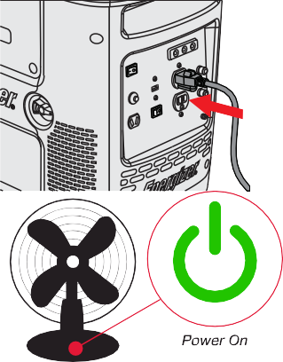
Using an EZG series generator to Charge Automotive Batteries

damage to the generator.
You can use 12V 8.3A DC output to charge automotive batteries. Be sure to monitor the battery charge time. Overcharging may cause explosion, injury, and

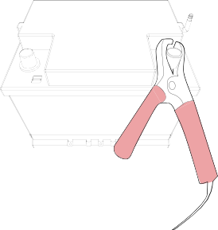
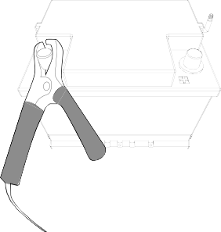
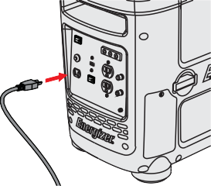
water and seek medical attention immediately.
during the charging process.

1. Connect the positive (red) terminal of the battery to the red (positive) terminal, the 12V 8.3A DC Output Terminal on the front panel of your generator.
2. Connect the negative (black) terminal of the battery to the black (negative) terminal, the 12V 8.3A DC output terminal on the front panel of your generator.

Do not reverse the polarity of these connec- tions.
3. Insert the DC plug into the DC receptacle. The generator should be running, and with EcoMode off. After insertion EcoMode may be turned on.

An explosive hydrogen gas is discharged through vent holes in the battery during
charging. Do not allow sparks or open flames around the generator or battery

Electrolyte fluid can burn eyes and clothing. Be extremely careful to avoid any
contact. If injured, wash the affected area immediately with large amounts of

When charging a large capacity battery or totally discharged battery, excessive
current may force the DC breaker to turn off. In this case, use a battery charger.

Chapter 5 — Maintaining Your EZG series Generator

Proper maintenance ensures safe, economical and trouble-free operation. Improper maintenance may cause the generator to malfunction and can lead to serious injuries. Contact Customer Support if you have any maintenance questions.

Maintenance Schedule

Item | Task | Daily | Every 20  Hours | Every 50  Hours | Every 100  Hours | Every 300  Hours
Generator | General Inspection | •
Engine Lubricants | Inspect Oil Level | •
 | Replace |  | •* |  | •
Air Filter | Inspection | •
 | Cleaning |  |  | •
Sediment Cup | Cleaning |  |  | •
Spark Arrester | Cleaning |  |  |  | •
Spark Plug | Inspection & Cleaning |  |  |  | •
 | Replacement |  |  |  |  | •
Valve Clearance | Inspection & Adjusting |  |  |  |  | •
Combustion Chamber | Inspection & Adjusting |  |  |  |  | •
Fuel Tank and Strainer | Cleaning |  |  |  |  | •
Fuel Line | Cleaning | Every two months (replace if necessary)
Exposed Metal Parts | Lubricate with oil | After every use and especially before storage
* For first use of the generator.

General Inspection Tips

    - Look for fuel leaks around the fuel tank, fuel hose, and fuel valve. Close the fuel valve and repair leaks immediately.
    - Look and listen for exhaust leaks while the engine is running. Have all the leaks repaired before continuing operation.
    - Check for dirt and debris and clean as necessary .
    - Check the engine oil level and add oil as necessary.
flammable and could explode under certain conditions.

Do not use gasoline or low flash point solvents for cleaning. They are

Cleaning The Air-Filter
Using gasoline or other flammable solvents can cause a fire or explosion.

    - Unscrew and remove the engine access panel.
Do not operate this product without an air filter.
    - Unscrew and remove the air filter assembly.
    - Remove the foam filter.
    - If the foam element is dirty, clean it in warm soapy water, rinse, and allow it to dry thoroughly, or clean in non-flammable solvent and allow to dry.
    - Dip the foam element in clean engine oil, then squeeze out all excess oil. The engine will smoke when started if too much oil is left in the filter.
    - Wipe dirt from the air filter unit and cover using a moist rag.

- Changing the Engine Oil

Used motor oil can cause skin irritations if left in long-term contact with skin. Wash hands thoroughly with soap and water after handling oil.
Do not dispose of used oil in drains or soil. Local service shops provide

    - Stop the engine and remove the oil access panel.
environmentally-friendly disposal methods.
    - Place a pan beside the generator.
    - Remove the oil drain screw and, using the oil drainage spout (found in your tool kit) allow the oil to completely drain into the pan.
    - Reinstall drain screw before filling the engine with fresh oil. Do not overfill oil reservoir. Use a funnel to prevent spillage. See chart below for recommended oil.
    - Reinstall the oil filler cap and tightly fasten.

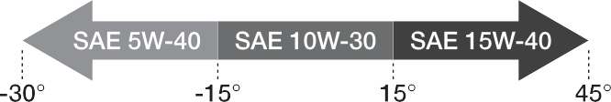
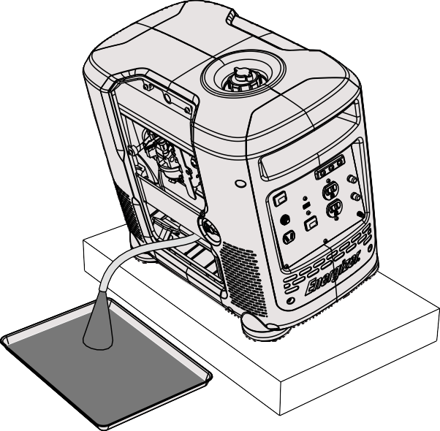

- Replacing and Cleaning the Spark Plug
overtighten the spark plug.

Do not rinse spark plug in water. Follow guidelines and be careful not to

Tighten ½ turn when installing a new spark plug. Tighten ¼ turn when re-installing an old spark plug.

    - Unscrew and remove spark plug access panel and screws.
    - Remove ignition coil from spark plug and remove spark plug with spark plug wrench.
    - Inspect the spark plug and clean any dirt from the electrodes with a wire brush. If electrodes are worn or show signs of wear, replace spark plug.
    - Measure the electrode gap with a spark plug gauge and adjust as necessary by bending the side electrodes. Ensure that the gap is between
0.7 and 0.9mm
    - Reinsert the plug carefully. Tighten with a spark plug wrench.

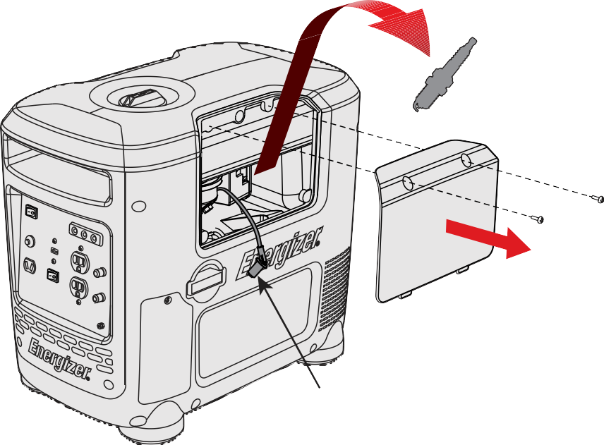
Spark Plug
Ignition Coil

- Handling and Storage

Handling
    - Turn off the power switch and the fuel valve when transporting the generator set.
    - Do not touch engine until the engine has cooled down.
    - Keep the generator at a level position in order to prevent spillage.

Storage
Before storing the generator set for an extended period:
- Ensure that the storage area is free of excess humidity and dust.
- Drain the fuel tank and the carburetor.
- To prevent corrosion, coat screws and exposed metal with antirust oil at least twice per year.

Draining the Fuel Tank
- Turn OFF the engine. Remove the fuel cap 1. Turn OFF the engine. Remove the fuel cap and the debris screen underneath the fuel cap.
- Empty the fuel tank into an approved gasoline container using a siphon.
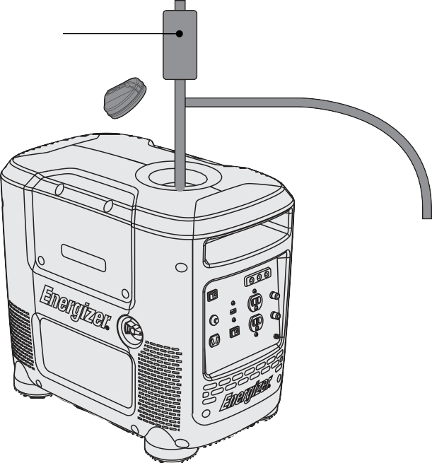
Syphon

6.0 Troubleshooting

Common issues can be fixed by following the instructions in this guide. If the unit will not function after following these instructions, contact technical support before attempting to use or repair the product.

PROBLEM | SYMPTOMS | CORRECTION
Generator will not start | Generator will not start | - The power switch is in the “Off” position. Switch to “On.”  - The engine is out of gasoline, add more.  - Engine choke is in wrong position. Adjust choke lever according to instructions on page 19.  - Faulty spark plug, replace with equal or greater quality plug. Refer to page 33 in your user’s manual for a complete list of spark plug compatibility codes.  - Insufficient oil, add more oil.  - Clogged fuel line, inspect gas tank for debris.
 | High resistance when pulling recoil starter. | - The engine does not have enough oil - add oi l.  - Air filter element obstructed by debris. Clean  according to user manual instructions on page 26.
Difficulty starting | Engine requires many attempts to start | - Disconnect load before starting.  - Incorrect oil being used. Please refer to the oil usage chart on page 27 in your user’s manual.  - Faulty spark plug, replace with equal or greater quality plug. Refer to page 33 in your user’s manual for a complete list of spark plug  compatibility codes.

Thick smoke released from exhaust | Exhaust fumes thick and dark | - Adjust choke lever according to user manual instructions on page 19.  - Incorrect oil being used. Use oil according to oil usage chart in user manual on page 27.  - Air filter element obstructed by debris. Clean according to user manual instructions on  page 26.
Generator does not produce power | No indicator lights or display on front panel | - Generator circuit breaker off or tripped  - Remove all loads, reset breaker, and check device for defects. Do not exceed generator rating.
Generator does not produce power (cont.) | Overload indicator light keeps flashing | - Adjust choke lever according to instructions on page 19.  - *When a connected device draws high startup power the overload and output indicator  light may briefly illuminate, but this is to be expected. Once the device starts up the overload indicator light will shut off and the output light will remain green.  - Ensure device wattage consumption does not exceed the generator’s maximum peak  output.
 | No DC output | - Disconnect battery, reset breaker and test the battery for shorts.  - Clean battery connector nodes.
Generator outputs unstable power | Connected device does not operate  consistently | 1. Verify device start up requirements (Wattage consumption). Do not exceed the generators maximum peak output.

 | Device will not start up | - Remove all loads, reset breaker, and check device for defects. Do not exceed generator rating.  - Ensure device’s wattage consumption does not exceed the generator’s maximum peak  output.
 | Engine idle unusually high or low | 1. Carburetor in need of tuning. For details on how to adjust correctly please contact your local service centre or contact Builder SAS
Generator overheats | Operation is normal when generator is cool, overheating occurs within moments of start up. | - Atmospheric temperature high (excess of 35°C).  - Insufficient air circulation in vicinity of generator.  - Low oil viscosity. Use oil according to oil usage chart in user manual on page 27.  - Fouled spark plug, replace with equal or  greater quality plug.
Engine idle fluctuates |  | - Carburetor in need of tuning. For details on how to adjust correctly please contact your local service centre or contact Builder SAS. Missing ground reference on return side of differential analog output (external).  - Air filter element obstructed by debris. Clean according to user manual instructions on  page 26

Engine stops | Engine idles down and shuts off | - The power switch is in the “Off” position.  - The engine is out of gasoline. Add regular unleaded gasoline.  - Air filter element obstructed by debris. Clean according to user manual instructions on page 26  - Adjust choke lever according to user manual instructions on page 20.  - Incorrect oil being used or insufficient oil level. Always ensure high oil levels, and use oil according to oil usage chart in user manual on page 27.  - Fouled spark plug, replace with equal  or greater quality plug. Refer below for a complete list of spark plug compatibility cod es.

SPARK PLUG COMPATIBILITY

BRAND | EZG SERIES
NGK | CR7HS
DENSO | U20FPR
CHAMPION | RZ10YC
BOSCH | U24BC

Chapter 7- Specifications

 |  | EZG2200I | EZG2800I
GENERATOR | Rated frequency (Hz) | 60 | 60
 | Rated AC Output Power (W) | 2000 | 2600
 | Max AC Output Power (W) | 2200 | 2800
 | 1-Phase Rated AC Voltage (V) | 120 | 120
 | Power Factor | 1.0 | 1.0
 | Max DC Output Power (W) | 100 | 100
 | Rated DC Voltage (V) | 12 | 12
ENGINE | Type | 3.80 HP, Single Cylinder, forced air cooling, 4-stroke, OHV | 5.3 HP, Single Cylinder, forced air cooling, 4-stroke, OHV
 | Displacement (cm3 or cc) | 125 | 150
 | Ignition mode | Transistor Controlled Ignition | Transistor Controlled Ignition
 | Starting mode | Recoil Start | Electric and Recoil Start
 | Max. Output (rpm) | 5000 | 4000/5000
 | Fuel tank capacity (Gal/Litres) | 1.85 / 7.0 | 1.85 / 7.0
 | Oil capacity | 450mL (10W30) | 450mL (10W30)
 | Fuel Type | 91 Oct. Unleaded Gasoline | 91 Oct. Unleaded Gasoline
 | Max. Running (Rated) Volume LWA dB | 89 | 92
BATTERY | Battery | N/A | 12V 7Ah
 | Nominal Voltage | N/A | 12V
SIZE | Packaging/Product Dimentions L x W x H (mm) | 570 x 350 x 530  540 x 320 x 480 | 570 x 350 x 530  540 x 320 x 480
 | Packaging/Product Weight (kg) | 35.5 / 33.5 | 42.3 / 37.4

INVERTER ASSEMBLY

YELLOW/GREEN 14# FROM CONTROL PANNEL TO GROUND

BLACK 12#

AC BREAKERS 30A

CONTROL PANEL

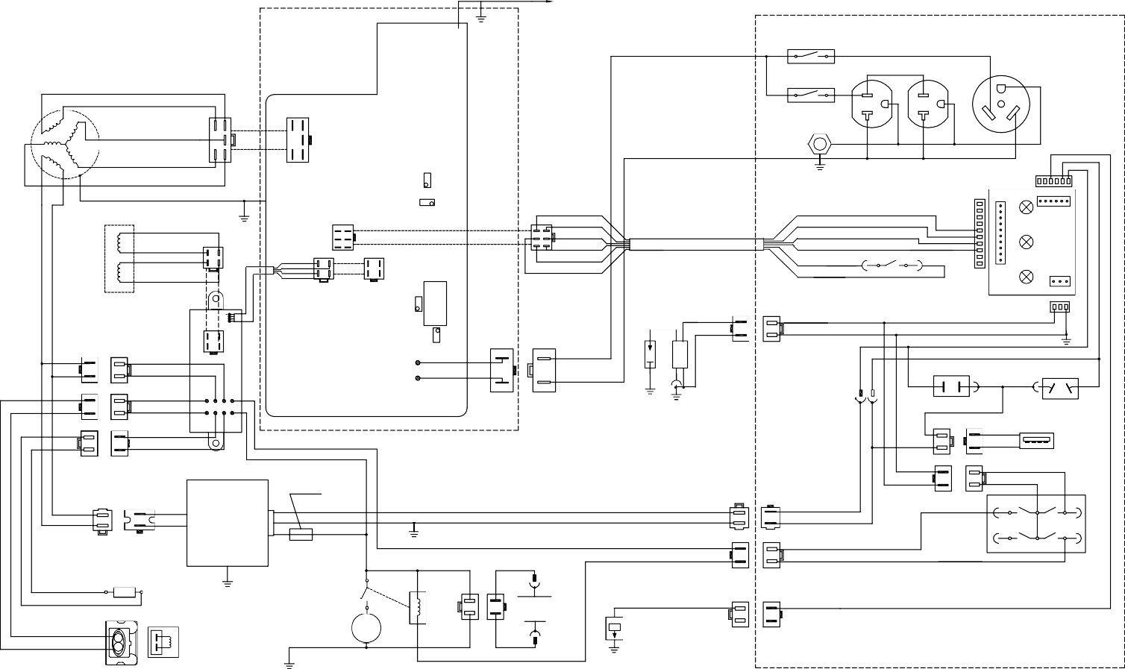
AC SOCKETS BLACK 12#

GENERATOR

WHITE 20#

WHITE 20#

INPUT

20A

BLACK 12#
20A
30A

BLACK 14#

BLACK 14#

BLACK 14#

GREEN

GREEN

VOLTAGE

WHITE 12#

GROUNDING

YELLOW/GREEN 14#

WHITE 20#
BLACK 20#
RED 20#

YELLOW/GREEN 14#

STEP MOTOR
RED 23#

WHITE

ECONOMY

BALANCE

BLACK

BLUE 20#

BROWN 20#

WHITE 20#

WHITE 20#

WHITE 20#
ORANGE 20#

BLACK 23#
SWITCH
RED 20# RED 20#

ECONOMY SWITCH
INDICATOR

WHITE 23#

BLUE 23#
BLACK 20#
RED 20#
WHITE 20#
BLUE 20#
ORANGE 20#

WHITE 20#
BROWN 20#

BLUE 20#

OVERLOAD

CURRENT

IGNITION COIL SPARK PLUG

BLUE 20#

BLACK 20#

WHITE

WHITE

RED 20#

BLACK 20#
35

BLUE 20#

BLUE 20#

YELLOW YELLOW

BLUE 20#

BLUE 20#

AC OUTPUT

BLACK 12#

WHITE 12#

DC BREAKER 10A

DC SOCKET

WHITE
WHITE

BLACK/WHITE 20#

GREEN GREEN

RED 20#

BLACK/WHITE 20#

YELLOW 20#

RED

RED

BLACK 16#

RED 16#

USB 5V/1A

RED 20#

WHITE

WHITE

WARRANTY

The manufacturer warrants the product against defects in materials and workmanship for a period of 2 years from the date of purchase to the original purchaser. The guarantee applies when the product is used as a home tool. The warranty does not extend for failures due to normal wear and tear.

The manufacturer agrees to replace the spare parts that are classified as defective by a designated distributor. The manufacturer will not accept responsibility for the replacement of the machine, either partially or in full, and / or consequential damages.

The warranty does not cover failures due to:
• Insufficient maintenance.
• Assembly, adjustment or abnormal operation of the product.
• Spare parts that are subject to wear.

Nor does the guarantee extend to:
• Cost of freight and packaging.
• The use of the tool for any other purpose than for which it was designed
• Use and maintenance of the machine in a manner not described in the user's manual.

As part of our policy of continuous product improvement, we reserve the right to alter or modify specifications without prior notice. As a result, the product may differ from the information contained herein, but any alteration will only be implemented without prior notice if it is classified as an improvement of the previous specification.

READ THE MANUAL CAREFULLY BEFORE USING THE MACHINE.

When ordering spare parts, please quote the part number or code, this can be found in the parts list included in this manual.

Keep the purchase receipt; Without it, no guarantee will be valid.

In order to get help about your generator, we invite you to go through this link or to call us by phone
+33 (0)8.20.20.22.68:

https://services.swap-europe.com/contact

You need to create a "ticket" via their platform.

- Login or create your account
- Put your tool reference
- Choose the subject of your request
- Explain your problem
- Attach these files: the invoice or receipt, the nameplate picture (serial number), the picture of the part you need (for example: pins on the transformer plug that broke away)

We offer you a warranty extension to 1 year. To profit it, please follow the below proceeding:

- Connect on the website:
- Insert your contact details
- Register your tool with:
- The reference
- The serial number
- The date you bought the tool
- Generate automatically the PDF warranty certificate and print it.

Declaration of conformity

BUILDER SAS
ZI, 32 RUE ARISTIDE BERGES – 312070 CUGNAUX – FRANCE
Declares that the machinery designated below: Gasoline Generator
Model: EZG2200i-EZG2800i
Serial number:
Complies with the provisions of the Directive “machinery” 2006/42/CE and national laws transposing it: Also complies with the following European directives:
EMC Directive 2014/30/EU ROHS Directive 2011/65/EU
Noise directive 2000/14/CE Annex VI + 2005/88/CE
Also complies with European standards, with national standards and the following technical provisions: EN ISO 8528-13:2016
EN 55012:2007/A1:2009
EN 61000-6-1:2007
Notified body of noise certificate: Intertek Testing & Certification Ltd. (Notified Body 0359) Sound power level measured: EZG2800I/ EZG2800iUK: 91.12 dB(A), K=0.89dB(A);
EZG2200I/ EZG2200iUK:87.09dB(A),K=1.15dB(A)
Guaranteed Sound power level: EZG2800I/ EZG2800iUK: 92 dB(A); EZG2200I/ EZG2200iUK:89dB(A)

Responsible for the technical file: Michel Krebs

Done at Cugnaux,

Philippe MARIE / PDG

